CS 305 Project One Template

Document Revision History

Version | Date | Author | Comments
1.0 | 09/19/2026 | Ezra Carter

Client



Instructions
Submit this completed vulnerability assessment report. Replace the bracketed text with the relevant information. In this report, identify your security vulnerability findings and recommend the next steps to remedy the issues you have found.

- Respond to the five steps outlined below and include your findings.
- Respond using your own words. You may also include images or supporting materials. If you include them, make certain to insert them in the relevant locations in the document.
- Refer to the Project One Guidelines and Rubric for more detailed instructions about each section of the template.

Developer
Ezra Carter

1. Interpreting Client Needs
Determine your client’s needs and potential threats and attacks associated with the company’s application and software security requirements. Consider the following questions regarding how companies protect against external threats based on the scenario information:

- What is the value of secure communications to the company?
- Are there any international transactions that the company produces?
- Are there governmental restrictions on secure communications to consider?
- What external threats might be present now and in the immediate future?
- What modernization requirements must be considered, such as the role of open-source libraries and evolving web application technologies?

Artemis Financial is a consulting company looking to develop and maintain financial applications used across the world. Because of the size and the scale of the information that this company is using secure communication both within the code base and the company itself is paramount to ensuring a safe and prosperous company. Due to its ties in the financial space Artemis is interlocked with markets and currency exchange across the world. By being in this sphere, they have opened themselves up to banking regulations in not just the United States but any country where they are managing assets in. This means Artemis is a prime candidate for targeted attacks due to the multitude of locations these assets may be stored in as well as the type of information being stored, shared, and gathered. It is the up most responsibility of this company to ensure that safe programming practices and adequate future proofing are performed to the highest standard possible, especially as Artificial intelligence is involved in the future. A recommendation for using strong open-source libraries, because of the amount of people involved in the creation and maintenance of said library, is highly recommended in order to ensure a strong codebase that can stand the test of time and resists as many outside attacks as possible.
2. Areas of Security
Refer to the vulnerability assessment process flow diagram. Identify which areas of security apply to Artemis Financial’s software application. Justify your reasoning for why each area is relevant to the software application.

- Input validation was the first and one of the most important things this is to at came. This is because customers’ financial information and data are going to be stored and handled. This makes the companies involved prime targets for SQL injections and other forms of user submitted attacks.
- APIs is another crucial element that cannot be ignored or neglected. Because we will be creating and using Apis within our apps utilizing strong and secure practices in the creation of our API is paramount. This will be used to prevent users from bypassing restrictions within the apps and gaining incorrect permissions.
- Cryptography is another key aspect that cannot be neglected. Since sensitive information will be stored and used throughout these apps if we are not careful and store this information incorrectly, we allow ourselves to be even more susceptible to data breaches and data leaks when they inevitably happen
- Client and server architecture is incredibly important and valuable when designing any application that is interacting with a server. This is incredibly important because it determines what each side will and should handle. For example, you would not put permissions, account balance, or have sensitive information stored on the client side as this makes the app more sensitive and easier to break. Likewise, the data stored server side must also be monitored and closely watched they can become incredibly vulnerable to DDOs Attacks or other types looking to shut down the app as a whole.
- Code error handling is something that can be easily overlooked. The reality of designing anything with programming is that bugs and errors are going to happen. It is our job to make sure that when errors do occur that the errors are made and that the programs perform predictably. When either of these are not done adequately it can lead to uncontrollable behaviors and thus make our applications weaker due to exploits.
- Code quality is something that goes in conjunction with my previous item. Bad code quality allows for exploits. Everything mentioned is rooted in safe programming practices it is important that are code both runs well and is done in a quality way. When either is ignored, it opens the door for exploits and makes fixing them a nightmare for anyone who program afterwards.
- Encapsulation is the final area that makes a secure application. Within programming and building our app we must be mindful and specifically with what information and data we allow to be read and to be modified. This is to prevent data being needlessly changed and goes to
3. Manual Review
Continue working through the vulnerability assessment process flow diagram. Identify all vulnerabilities in the code base by manually inspecting the code.

[Include your 7–10 findings here.]
- 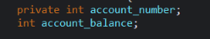 Int account should be private as making it public allows for outside sources to easily change it’s totals with no checks or balances. Furthermore neither should allow for negative numbers to be chosen
- 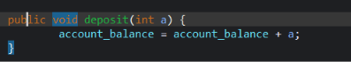 deposits should not be handled client side and the integer must be check to make sure it’s positive. Allows for negative numbers to get through.
- 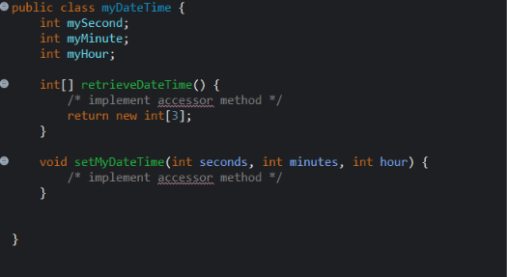 no limit to number of minutes hours and seconds one can put allowing for both users and classes to potentially set insane times furthermore my second minute and hour are both public allowing outside classes to directly mess with then and has no default constructor allowing blank classes with null values to be created plus should not be easily accessible and should be private.
- 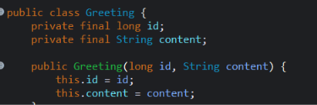 allowing for creation of empty strings and negative id potentially causing issues when trying to pass information into other classes
- 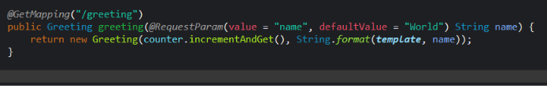 Does not deal with negative numbers allowing for the code as a whole to start assigning negative values if an long overflow happens and making vulnerable to hackers.
- 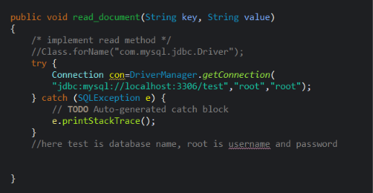database information stored in comments and within the code itself making potential code leaks even more dangerous
- 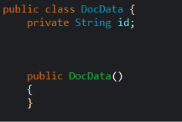 unfinished constructor meaning string will always be null and cause issues if other classes calls for get id.
- 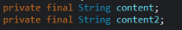 Naming conventions will cause issues especially with how similar it is
- 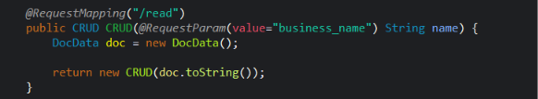 no input validation. blindly trusting user submitted information is never a good idea
4. Static Testing
Run a dependency check on Artemis Financial’s software application to identify all security vulnerabilities in the code. Record the output from the dependency-check report. Include the following items:

- The names or vulnerability codes of the known vulnerabilities
- A brief description and recommended solutions provided by the dependency-check report
- Any attribution that documents how this vulnerability has been identified or documented previously

Names/Code | Vulnerability | Brief Description | Attributes | Solutions
bcprov-jdk15on-1.46.jar | cpe:2.3:a:bouncycastle:bouncy-castle-crypto-package:1.46:*:*:*:*:*:*:*  cpe:2.3:a:bouncycastle:bouncy_castle_crypto_package:1.46:*:*:*:*:*:*:*  cpe:2.3:a:bouncycastle:bouncy_castle_for_java:1.46:*:*:*:*:*:*:*cpe:2.3:a:bouncycastle:legion-of-the-bouncy-castle-java-crytography-api:1.46:*:*:*:*:*:*:*  cpe:2.3:a:bouncycastle:the_bouncy_castle_crypto_package_for_java:1.46:*:*:*:*:*:*:* | Allowing of invisible data into a signed structure due to failure if DSA to validate ASN1  Timing issue with EC math library that can expose private keys  DDos potential due to parsing a file that has a crafted ASN1 data  Does not validate a point within the elliptic curve making it easier for attackers to obtain a private key | http://www.bouncycastle.org/licence.html | Download latest version of software
hibernate-validator-6.0.18.Final.jar | cpe:2.3:a:hibernate:hibernate-validator:6.0.18:*:*:*:*:*:*:*  cpe:2.3:a:redhat:hibernate_validator:6.0.18:*:*:*:*:*:*:* | By default may interpolate user supplied input in a constraint violation expressed language allowing sensitive information to be access or execute arbitrary Java code  Allowance of HTML injections or Cross site Scripting due to a flaw in hibernators is Valid Method  A bug in the message interpolation process allowing hackers to bypass input sanitation. | http://www.apache.org/licenses/LICENSE-2.0.txt
jackson-databind-2.10.2.jar | cpe:2.3:a:fasterxml:jackson-core:2.10.2:*:*:*:*:*:*:*  cpe:2.3:a:fasterxml:jackson-databind:2.10.2:*:*:*:*:*:*:*  cpe:2.3:a:fasterxml:jackson-modules-java8:2.10.2:*:*:*:*:*:*:* | Allowance of arbitrary class instantiation due to a failure of arbitrary class instantiation  Vulnerable to DDos attack due to a Stack overflow error or via JDK serialization | http://www.apache.org/licenses/LICENSE-2.0.txt
log4j-api-2.12.1.jar | log4j-api-2.12.1.jar | Vulnerable to DDos attacks due to a vulnerability in a serialization in log back error  An attacker with permission to edit configuration files could execute arbitrary code execution | http://www.eclipse.org/legal/epl-v10.html, http://www.gnu.org/licenses/old-licenses/lgpl-2.1.html | Update to latest version
logback-core-1.2.3.jar | cpe:2.3:a:qos:logback:1.2.3:*:*:*:*:*:*:* | Vulnerable to DDOS (Denial of service Attacks as well as those with configuration permission can craft malicious code | https://www.apache.org/licenses/LICENSE-2.0.txt | Update to latest version of software and configure permissions properly
snakeyaml-1.25.jar | cpe:2.3:a:snakeyaml_project:snakeyaml:1.25:*:*:*:*:*:*:* | Vulnerable to DDos attack via multiple methods due to its parser  Remote Code execution possible due to the fact Yaml does not restrict types before | http://www.apache.org/licenses/LICENSE-2.0.txt
spring-boot-2.2.4.RELEASE.jar | cpe:2.3:a:vmware:spring_boot:2.2.4:release:*:*:*:*:*:* | Vulnerable to temporary directory hijacking  Potential for a DDos attack when used with a reverse proxy cache  if running on the same network as the server vulnerable to timing attack that allows for Remote code execution  ArtemisEmbeddedConfigurationFactory uses a fixed static path when no explicit path is given allowing hackers on the host to recreate this directory or symlink before it starts | https://www.apache.org/licenses/LICENSE-2.0
spring-core-5.2.3.RELEASE.jar | cpe:2.3:a:pivotal_software:spring_framework:5.2.3:release:*:*:*:*:*:*  cpe:2.3:a:springsource:spring_framework:5.2.3:release:*:*:*:*:*:*  cpe:2.3:a:vmware:spring_framework:5.2.3:release:*:*:*:*:*:* | When used in conjunction with Tomcat as a war deployment is vulnerable to a Remote code Execution.  vulnerable to Privilege escalations by recreating the temporary storage directory  memory leaks due to a malformed frame  vulnerable to stream corruptions when Server-Sent Events are preformed  when a Content-Disposition header is used vulnerable to http response splitting  Vulnerable to cache poisoning | https://www.apache.org/licenses/LICENSE-2.0 | Update to latest version
spring-web-5.2.3.RELEASE.jar | cpe:2.3:a:pivotal_software:spring_framework:5.2.3:release:*:*:*:*:*:*  cpe:2.3:a:springsource:spring_framework:5.2.3:release:*:*:*:*:*:*  cpe:2.3:a:vmware:spring_framework:5.2.3:release:*:*:*:*:*:* | When used in conjunction with Tomcat as a war deployment is vulnerable to a Remote code Execution.  vulnerable to DDOs attacks via numerous different methods  Memory leak via a malformed setup frame  Attackers utilizing undeleted temp files within the system can consume available disc space on the server  Vulnerable to redirect attacks because of lack of configured prefix  Vulnerable to cross site scripting vulnerable due to data binding errors  Case sensitive on disallowed fields allowing  Cache poisoning is possible when resolving static resources | https://www.apache.org/licenses/LICENSE-2.0 | Update to the latest version
tomcat-embed-core-9.0.30.jar | cpe:2.3:a:apache:tomcat:9.0.30:*:*:*:*:*:*:*  cpe:2.3:a:apache_tomcat:apache_tomcat:9.0.30:*:*:*:*:*:*:* | AJP Protocols are treated as a higher priority than other connections allowing hackers to have arbitrary files be returned.  Can also allow for hackers to inject malicious code via a partial put request  Race condition on case insensitive files when the default servlet is enable for write | https://www.apache.org/licenses/LICENSE-2.0.txt | Update to the newest version
tomcat-embed-websocket-9.0.30.jar | cpe:2.3:a:apache:tomcat:9.0.30:*:*:*:*:*:*:*  cpe:2.3:a:apache_tomcat:apache_tomcat:9.0.30:*:*:*:*:*:*:* | AJP Protocols are treated as a higher priority than other connections allowing hackers to have arbitrary files be returned.  Can also allow for hackers to inject malicious code via a partial put request  Race condition on case insensitive files when the default servlet is enable for write | http://www.apache.org/licenses/LICENSE-2.0.txt | Update to the newest version

5. Mitigation Plan
Interpret the results from the manual review and static testing report. Then identify the steps to mitigate the identified security vulnerabilities for Artemis Financial’s software application.

- For starters input validation wherever data is being collected from the users is paramount in this code base. There are numerous places where data is being passed around without properly checking that this data is safe and secure to pass to the users.
- Proper encapsulation is another area that can be improved especially as there are numerous variables that are public, allowing outside sources to potentially cause chaos
- Proper boundaries are plans for when unexpected data is generated throughout the codebase Numerous integers, longs, and strings have no constructors or allows for negative numbers to be inserted and appear. This allows for the many potential bugs to be present.
- Not storing the passwords inside the code itself or especially the comments in case data breaches happen
- Better naming conventions as numerous variables share the same name causing potential confusion and mistakes to get pushed to production
- Updating to the latest and most secure version of dependencies should allow for the most secure platform. Institute an auto update feature can further make our application more secure and reduce the risk of forgetting a key dependency

